# SQS

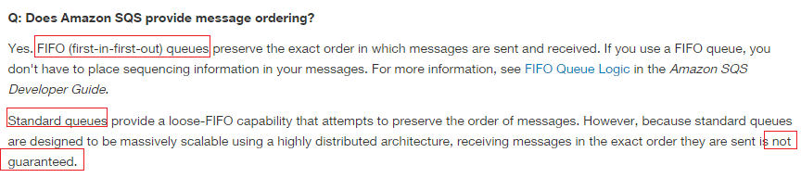

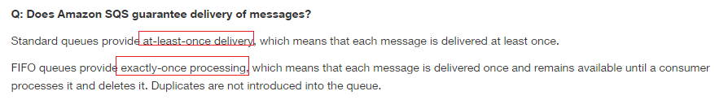

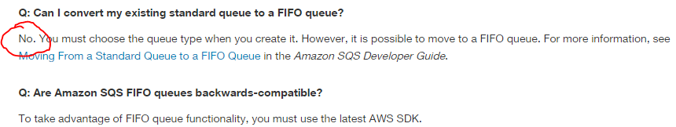



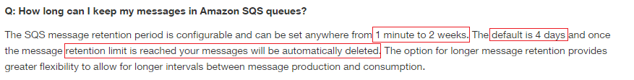

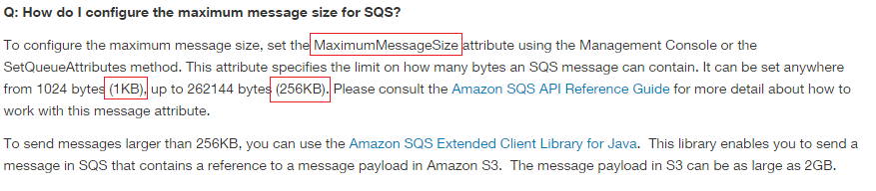



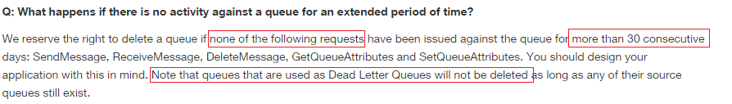



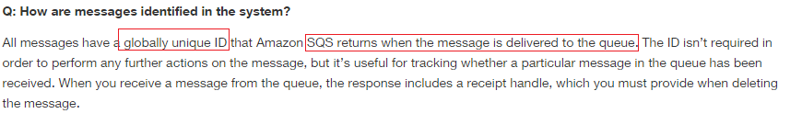

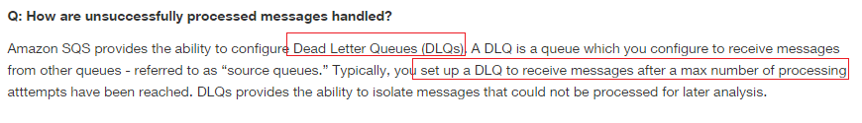

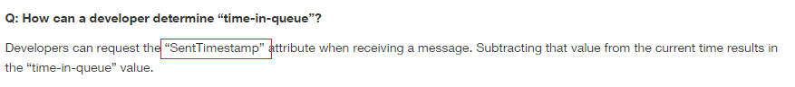



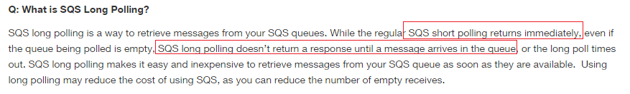

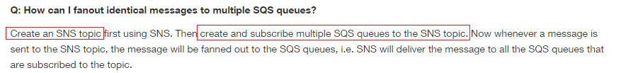

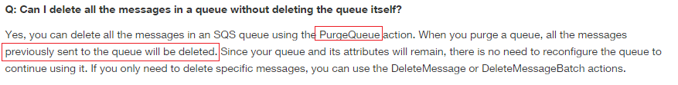

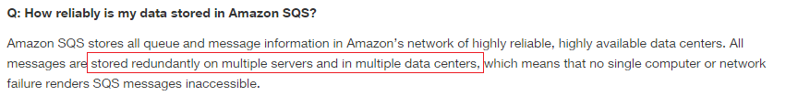

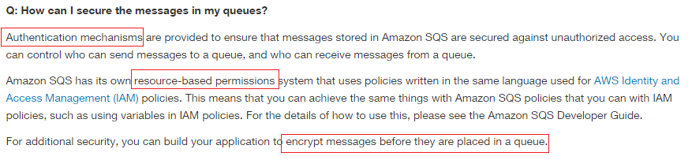



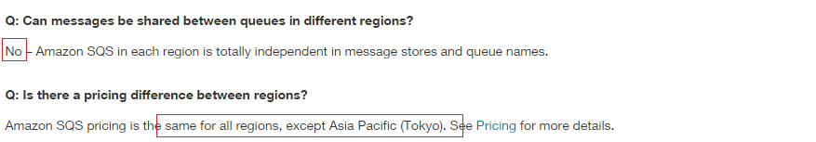

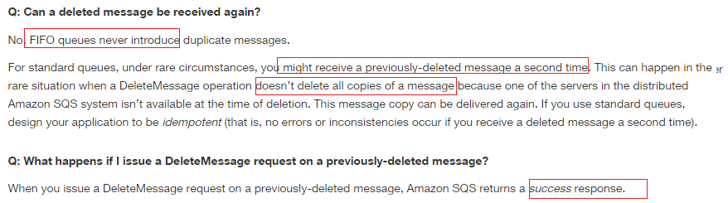

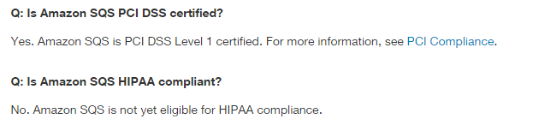

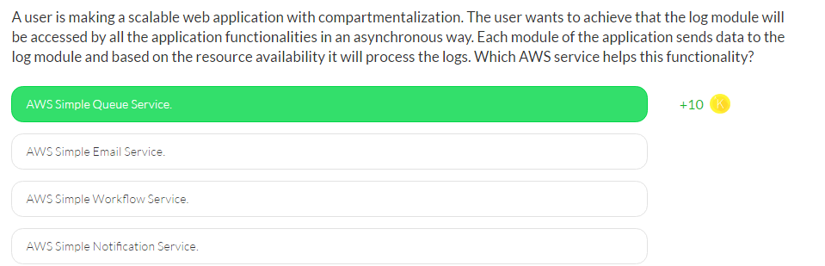

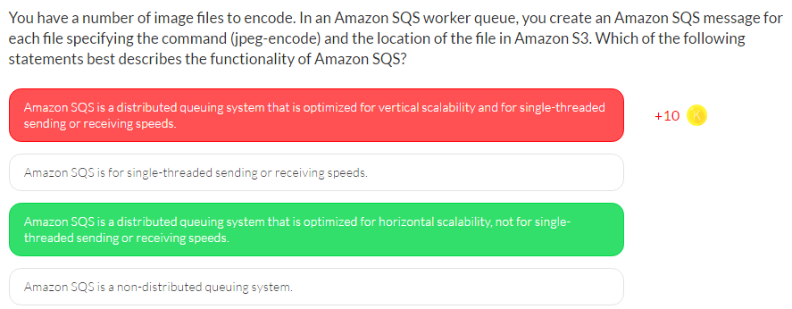

Amazon SQS is a distributed queuing system that is optimized for horizontal scalability, not for single-threaded sending or receiving speeds. A single client can send or receive Amazon SQS messages at a rate of about 5 to 50 messages per second. Higher receive performance can be achieved by requesting multiple messages (up to 10) in a single call. It may take several seconds before a message that has been to a queue is available to be received

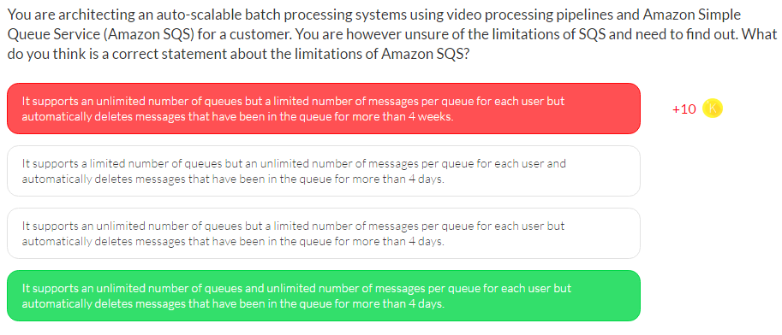

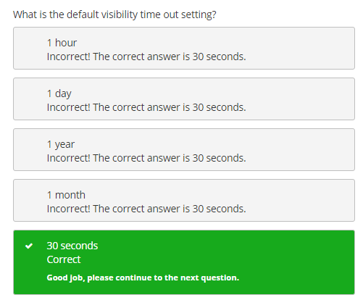

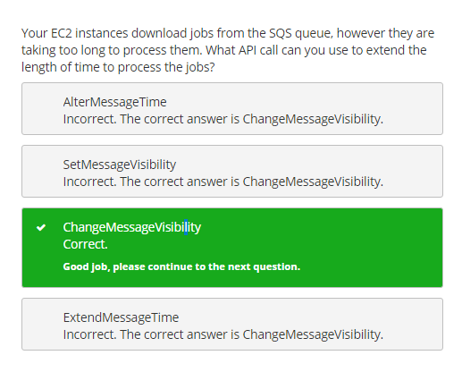

# SES

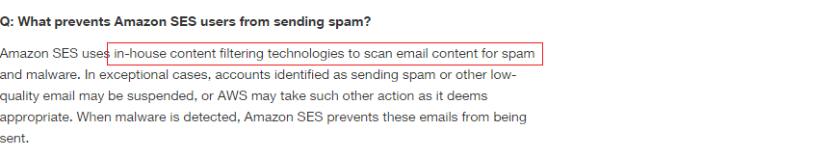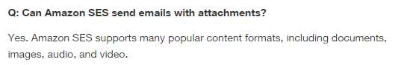

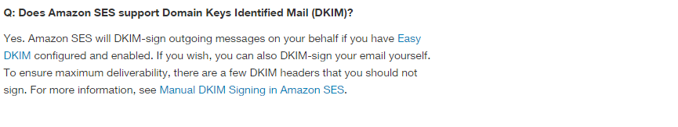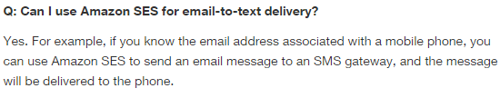

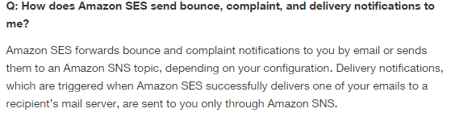

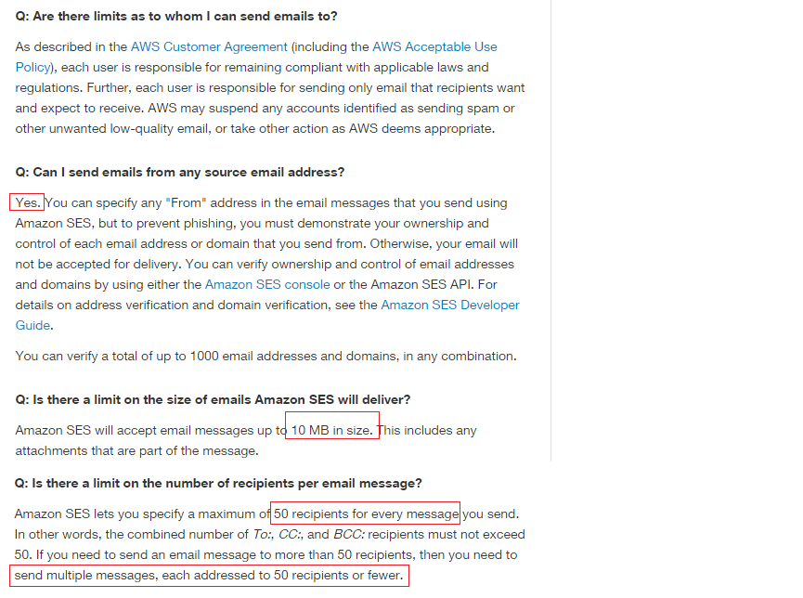

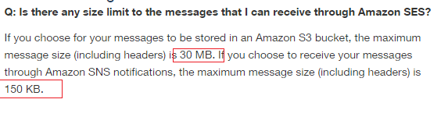

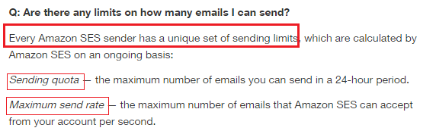

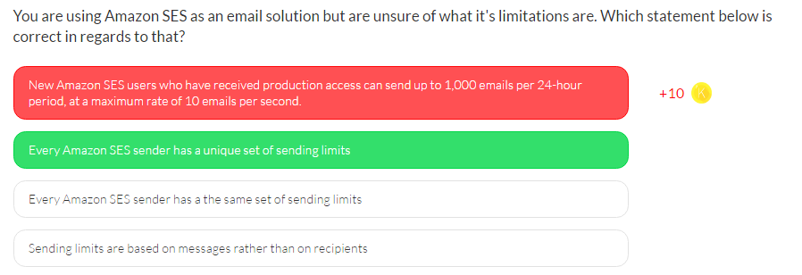

Amazon Simple Email Service (Amazon SES) is a highly scalable and cost-effective email-sending service for businesses and developers. Amazon SES eliminates the complexity and expense of building an in-house email solution or licensing, installing, and operating a third-party email service for this type of email communication.

* Every Amazon SES sender has a unique set of sending limits, which are calculated by Amazon SES on an ongoing basis:
  + Sending quota — the maximum number of emails you can send in a 24-hour period.
  + Maximum send rate — the maximum number of emails you can send per second.
* New Amazon SES users who have received production access can send up to 10,000 emails per 24-hour period, at a maximum rate of 5 emails per second. Amazon SES automatically adjusts these limits upward, as long as you send high-quality email. If your existing quota is not adequate for your needs and the system has not automatically increased your quota, you can submit an SES Sending Quota Increase case at any time.
* Sending limits are based on recipients rather than on messages. You can check your sending limits at any time by using the Amazon SES console.

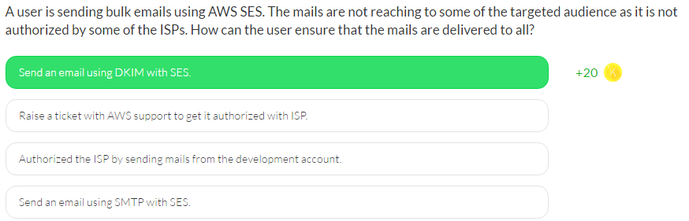

**Domain Keys Identified Mail (DKIM)** is a standard that allows senders to sign their email messages and ISPs can use those signatures to verify that those messages are legitimate and have not been modified by a third party in transit.

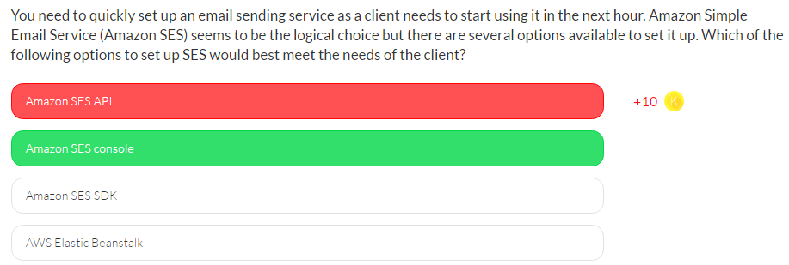

There are several ways that you can send an email by using Amazon SES.

* Amazon SES console (quickest way)
* Amazon SES API.
* SMTP interface

# SNS

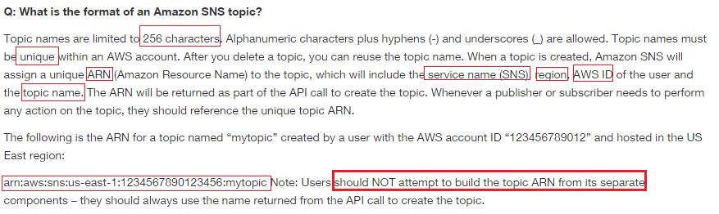

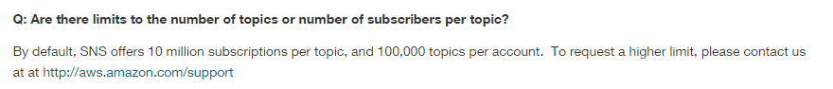

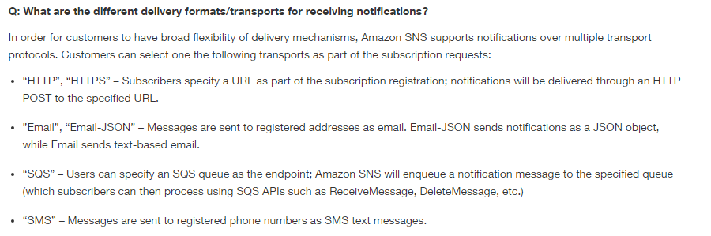



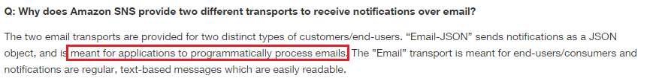

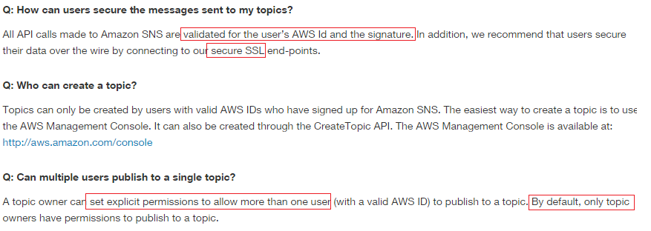

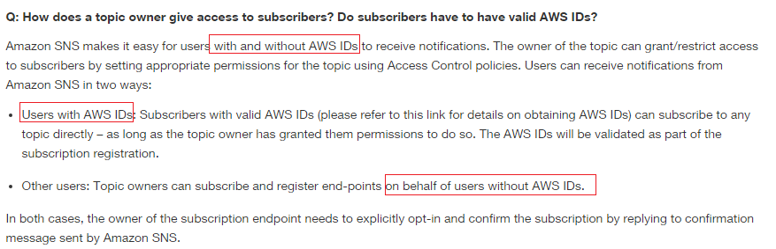

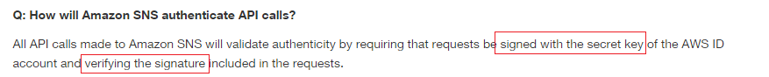



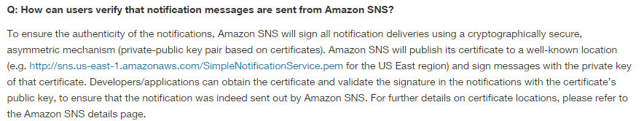



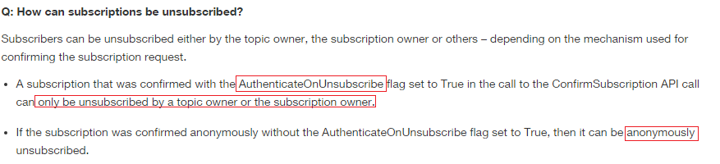

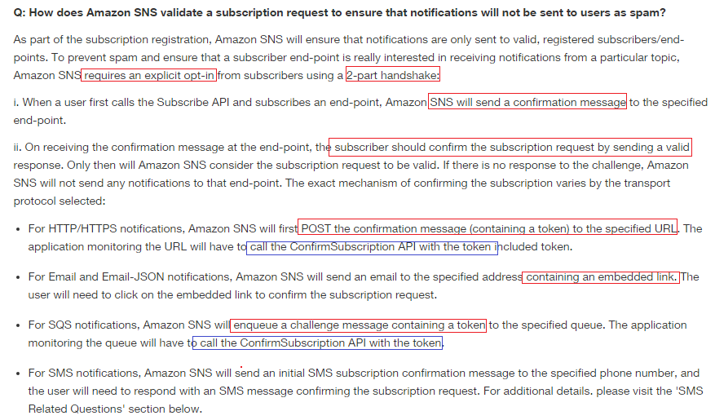



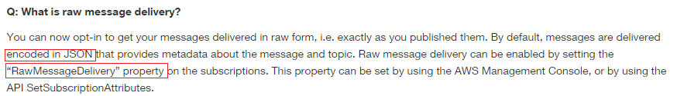

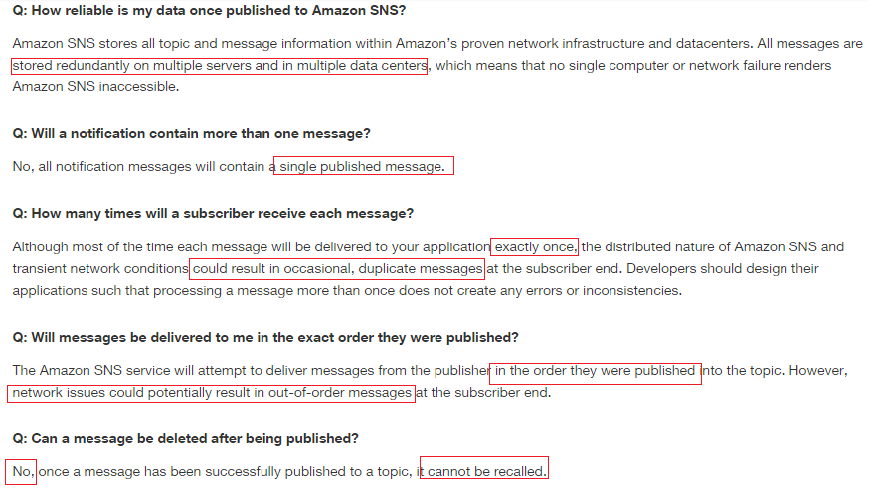

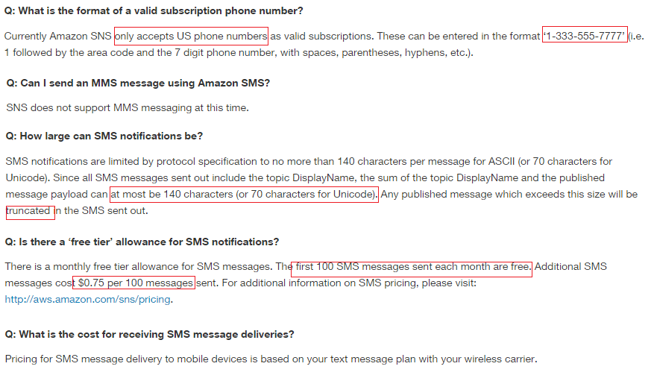

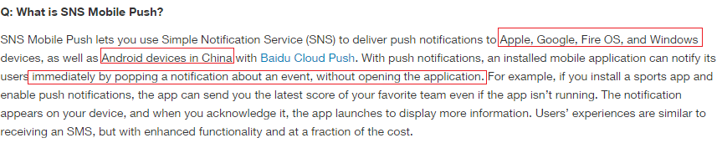

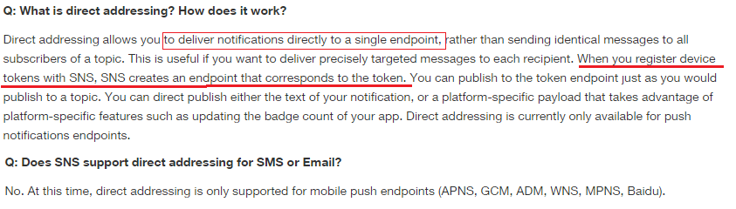

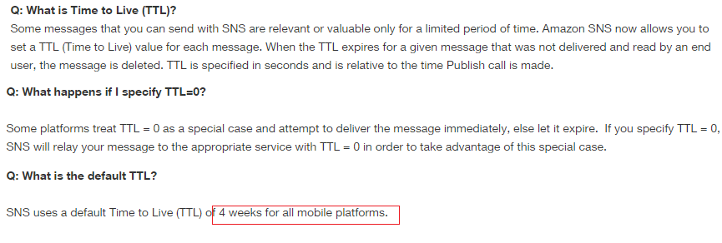

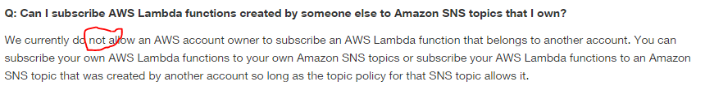

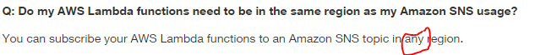

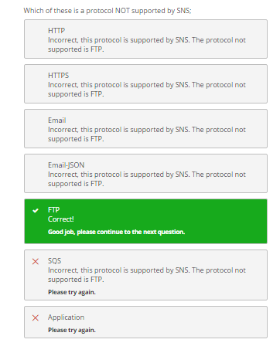

# SWF



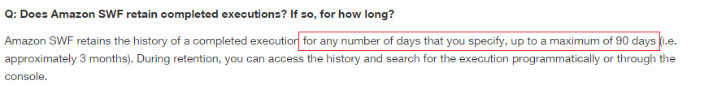

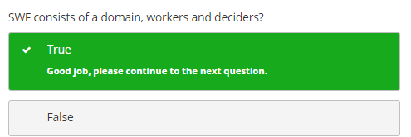

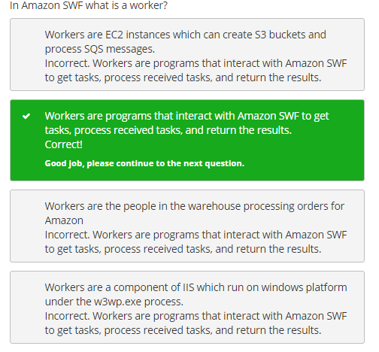

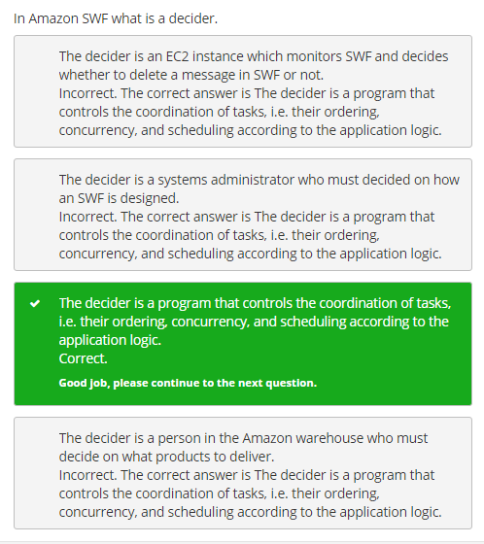

# Elastic Encoder

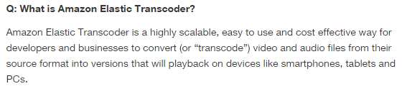

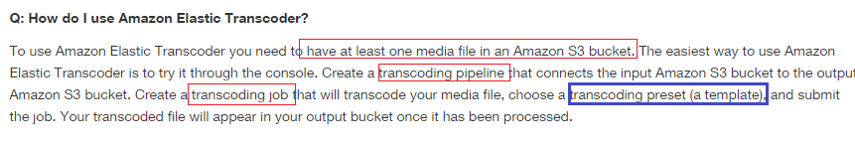

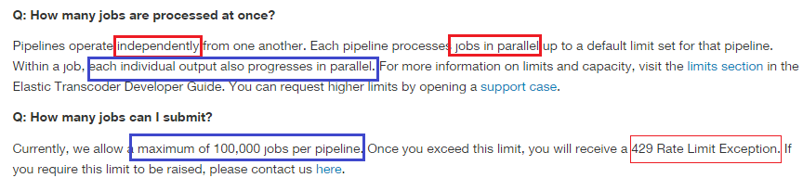

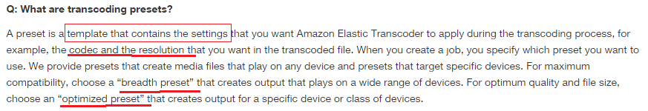

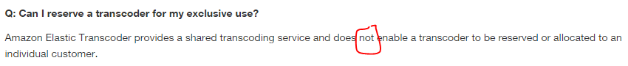

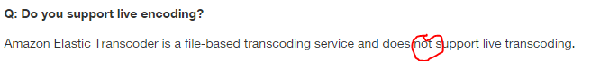

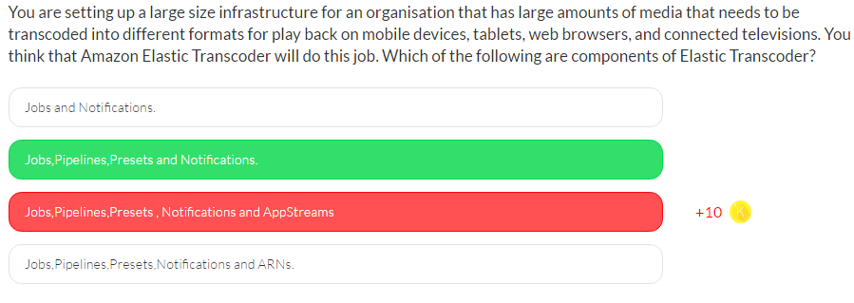

Elastic Transcoder has four components:

* Jobs
* Pipelines
* Presets
* Notifications

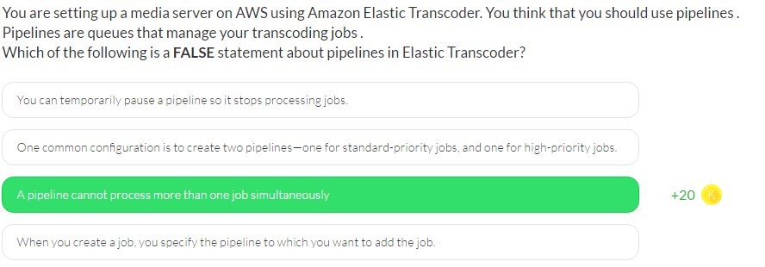

# Cloud Search

